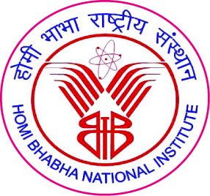 | Homi Bhabha National Institute

Ph.D. PROGRAMME

ORAL GENERAL COMPREHENSIVE EXAMINATION REPORT (OGCE)

Name of the Student:

- Name of the Constituent Institution:

3. Enrolment No.:

4. Board of Studies:

The Oral General Comprehensive Examination of Shri /Ms._____________________ was conducted on _________. The monitoring / doctoral committee is fully satisfied with his/ her performance and permits him/ her to continue with his/ her Ph.D. programme.

The student has studied research methodology theory and on examination was found to be proficient in research methodology as applicable to his/her field of study. He/She fulfills the criterion 4 and criterion 6 of UGC 11 point criteria.

Doctoral Committee:
S. No. | Doctoral Committee | Name | Signature | Date
1. | Chairman
2. | Guide/Convener
3. | Co-Guide (if any)
4. | Member-1
5. | Member-2
6. | Member-3
7. | Technology Advisor (if any)

Signature

Dean-Academic
To
Dean, HBNI
C.C. All monitoring committee members and reporting Student

A second chance may be given if not fully satisfied with the performance of the student.

